|  |  |
| --- | --- |
| Student Name | Sameer Sharma |
| Course Name | Caltech Coding Bootcamp |
| Cohort Information | CB FSD OCT 2024 COHORT 1 |
| Course # | 3 |
| Course Title | API End Points and Communication |
| Project | Course-end Project 1 – My Cab Buddy |

# Problem Statement

George owns a travel company where he books cabs for his customers. To manage these bookings, he needs travel management software. He meets Kia, who runs a Software Solution Company and tells her the requirement.

Kia aims to develop the project using Spring and the Spring Boot Framework. She must create micro-services to provide a solution using a REST architecture and perform unit testing for various web methods.

## Approach

### Booking

BookingID (unique/PK)

Pickup location (Source)

Destination

Distance

Rate

Final Amount

Confirmation Number (unique)

Email (Customer email)

### Customer

CustomerID (unique/PK)

Name

Email (unique)

PhoneNumber

PaymentMethod

### Architecture

Eureka Server

Micro-Service #1 – Booking

Micro-Service #2 – Customer portal

Database – MySQL

View Technology – Thymeleaf

### Project Details

|  |  |
| --- | --- |
| Projects | Port Numbers |
| Eureka server | 8761 |
| Customer micro-service | 8762 |
| Booking micro-service | 8763 |
| MySQL database name | my_cab_buddy |

Eureka Server

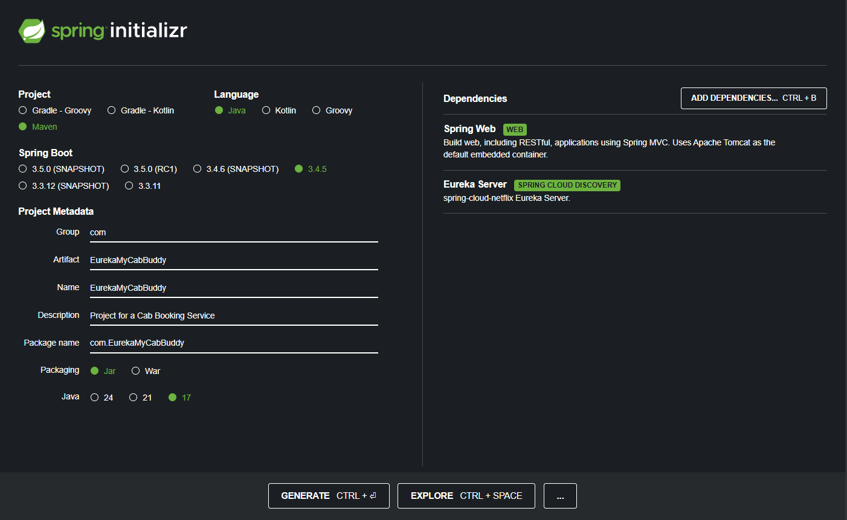

Customer Project

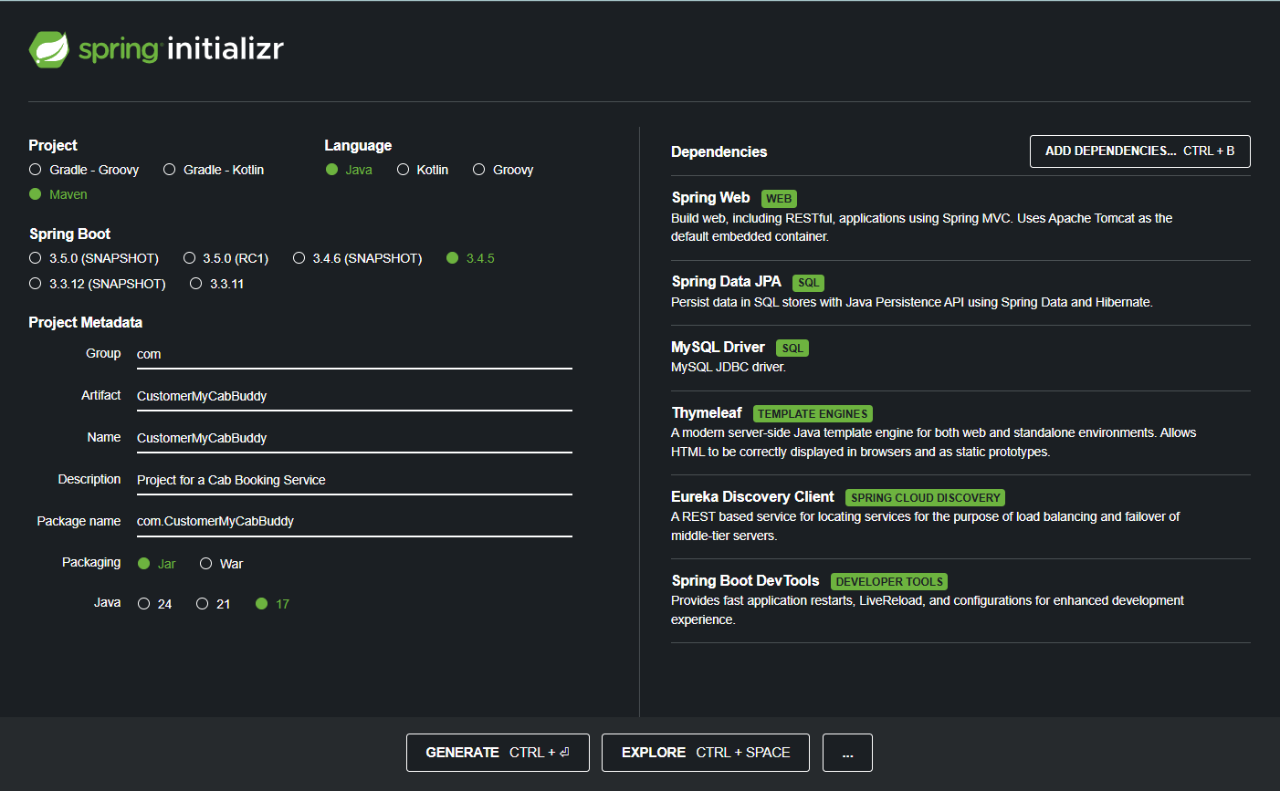Booking Project

